# Rancher Desktop for Window 10/11 PRO

Pre-Requisites:

1. Windows 10 **PRO** version 1909 or Higher

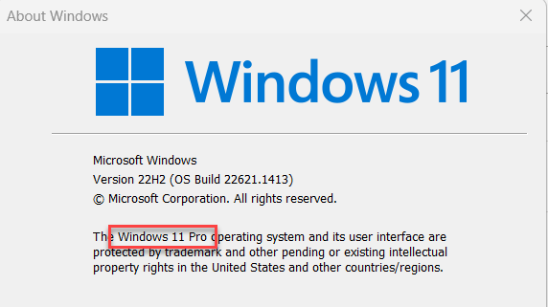

1. CPU Level Virtualization Enabled from Your System BIOS

*See Note 1 Below*

1. Hyper-V Installed and Enabled

***See Note 2 Below***

## Note 1: How to Enable CPU Level Virtualization from System BIOS (UEFI in modern Systems)

1. Close All the running applications and Goto Start Menu
2. Press and HOLD SHIFT key while clicking “Restart” button.

NOTE: After Windows began restarting leave shift key.

1. Wait for Windows to show a full screen menu with choices:

Choose “Troubleshoot”

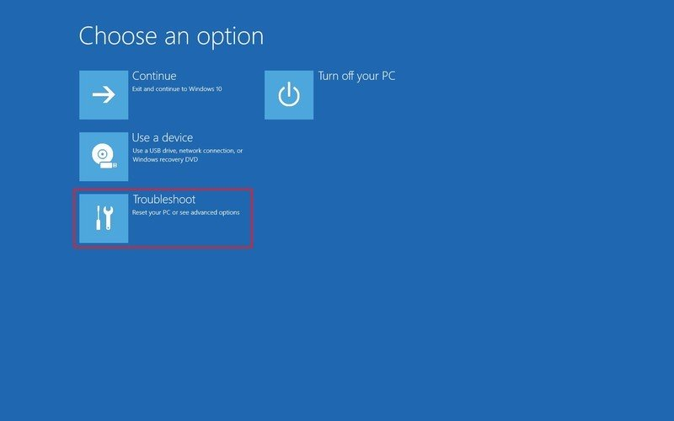

1. Click on “Advanced options”

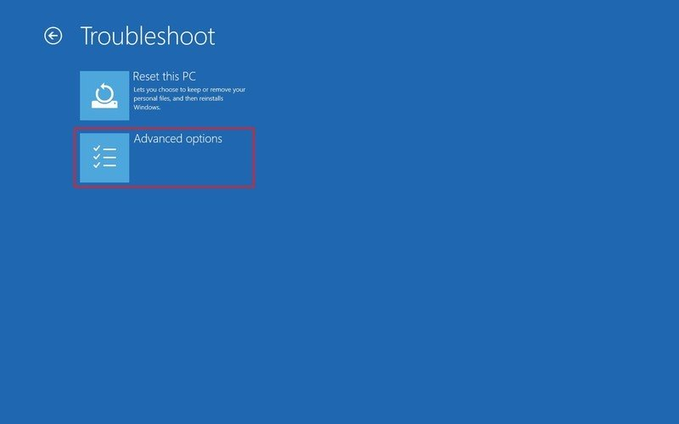

1. Click “UEFI Firmware Settings”

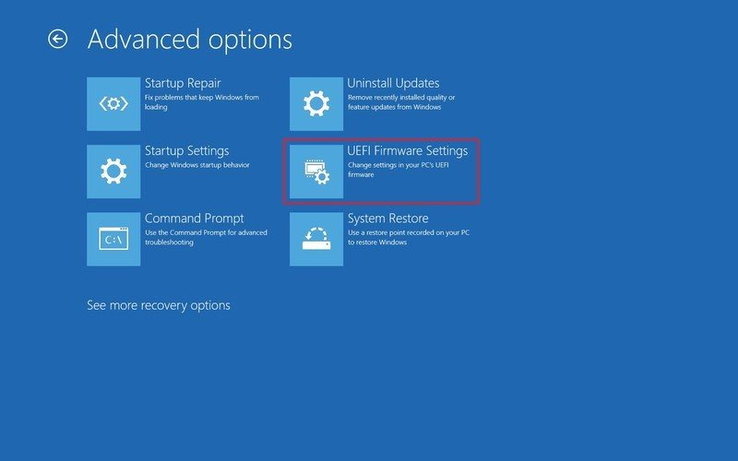

1. Now, proceed to restart

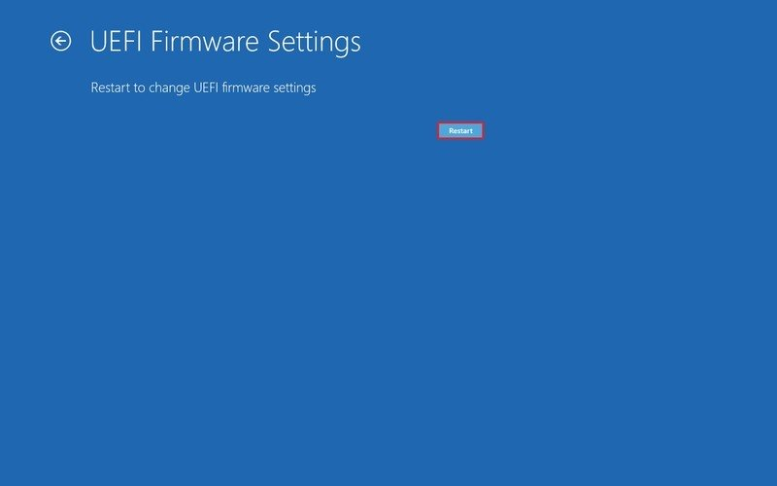

1. Once You are inside BIOS/UEFI Setup screen, look out for Virtualization and Enable it.

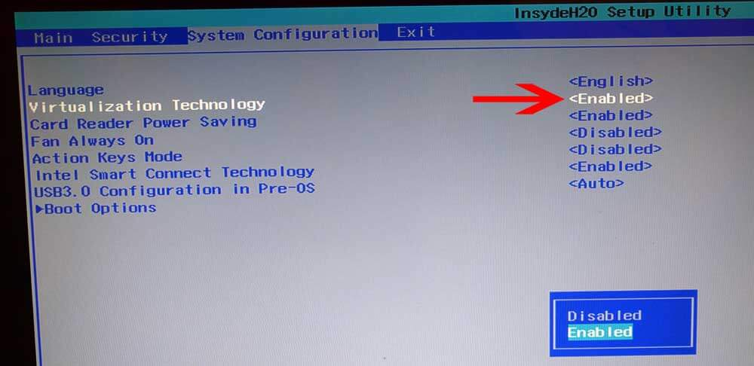

Then Proceed to Save and Exit.

## Note 2: Installing Hyper-V and Container Support in Windows 10 PRO

1. Using Start Menu Try opening “Powershell” in Administrator mode.

1. Once in powershell, use following command to enable “HyperV” and Containers”

Enable-WindowsOptionalFeature -Online -FeatureName Containers -All -NoRestart

wsl --install

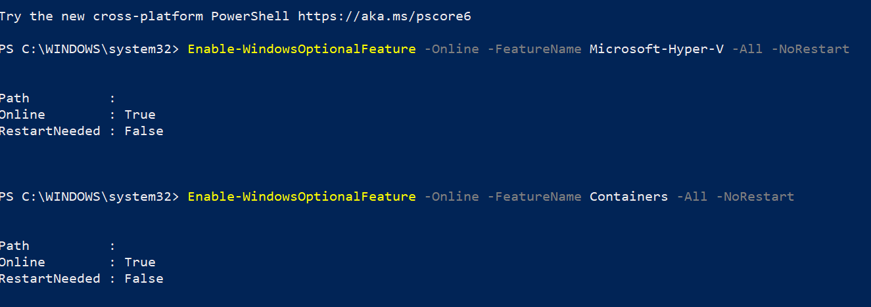

1. You need to restart your system.

## Rancher desktop Installation

Download the setup from below link <https://ranchardesktop.io>

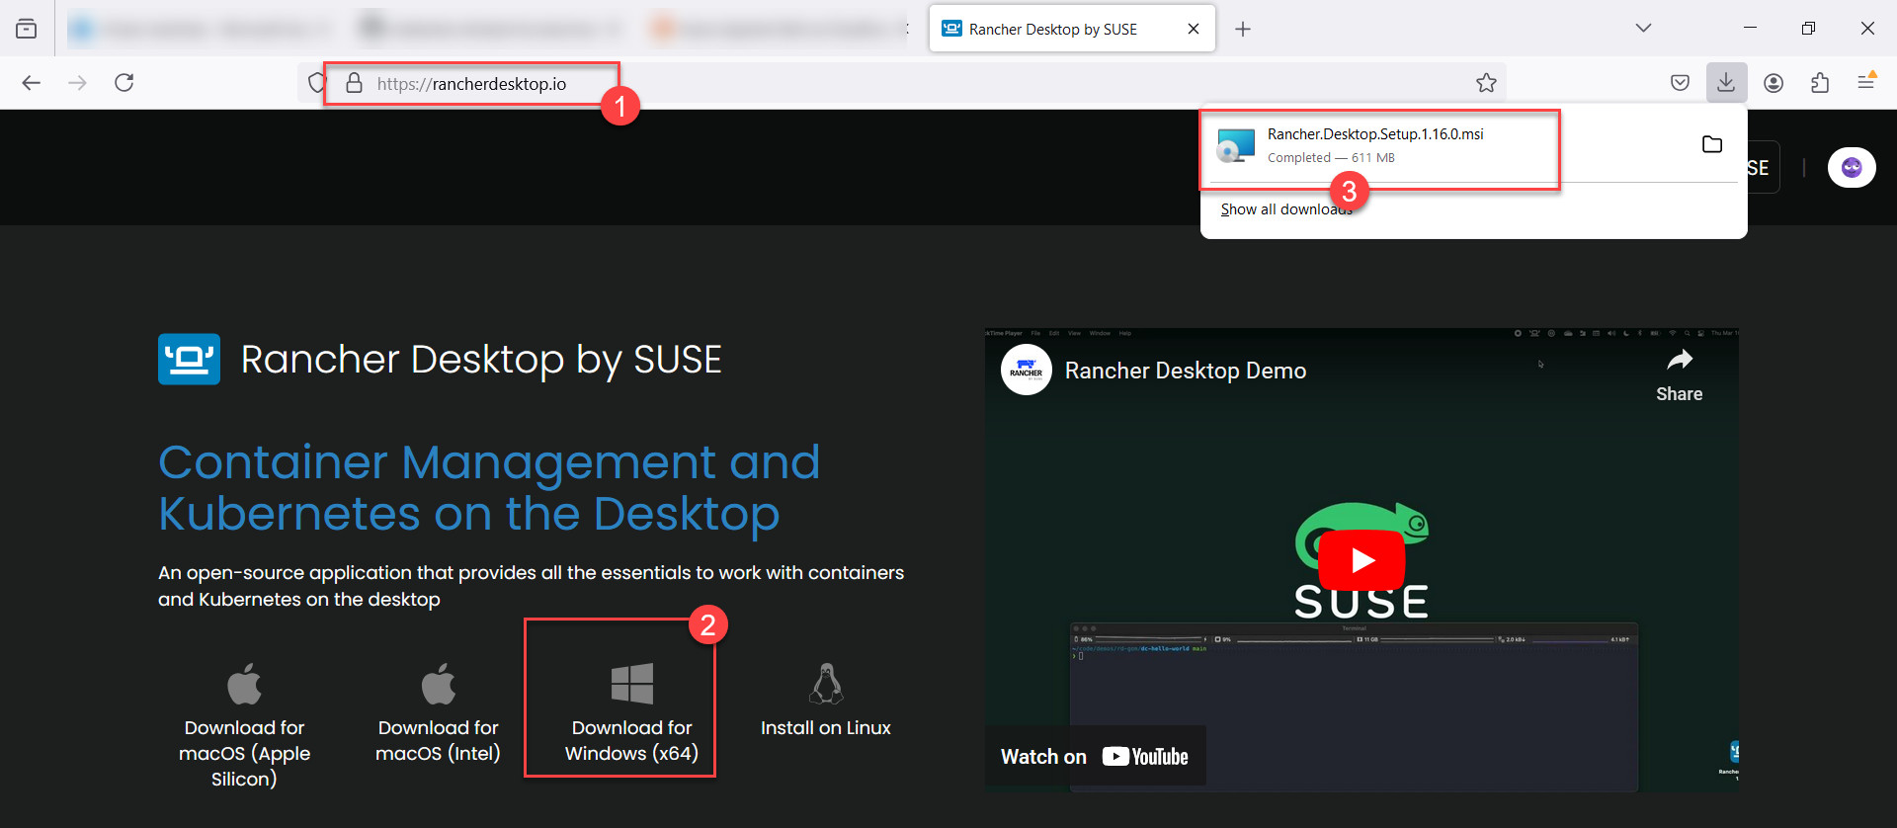

Make sure, you download “Windows x64” version of Rancher Desktop.

1. Launch the downloaded setup.

1. Keep default option (Install for All Users) and click Next.

1. Click “Install” to start installation.

1. Check option “Run Rancher Desktop” and click “Finish”

1. Now, choose “Kubernetes” version, Container engine then click “Ok”

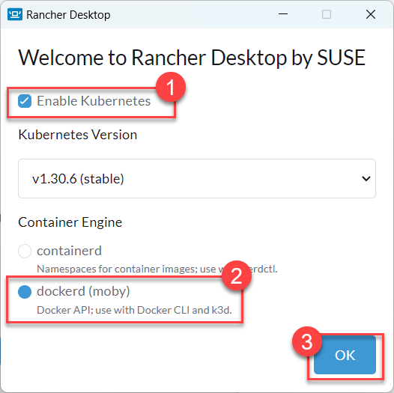

1. Using Either Powershell or Command Prompt (CMD) try following command to know status of Kubernetes.

kubectl config get-contexts

kubectl cluster-info

In-case of an error, please ignore and wait till the training day.

## Visual Studio Code

1. Download VisualStudio Code from <https://code.visualstudio.com>

1. Download the Setup file and follow on-screen instructions

1. Accept The Licence Agreement And click next to continue setup

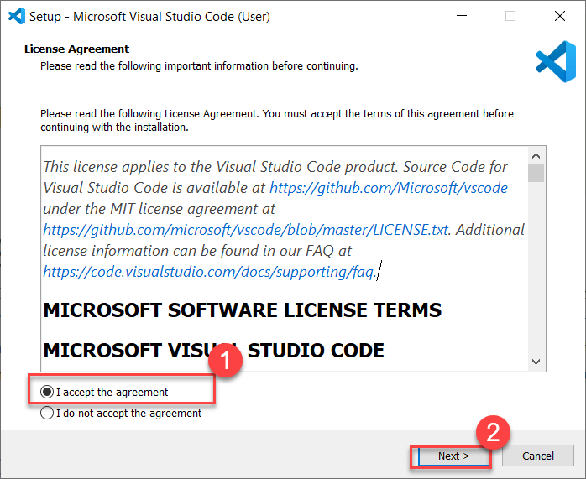

1. Just Wait for the Installation to Complete after you click “Install” button.
2. Click “Finish” to close installer when finished.